EXPERIMENT 8

Name: Arav Desai | Roll No: 3
Subject: SSSL | Class/Batch: AIML A\B1
Date of Performance: 21/3/2025 | Date of Submission:28/3/2025

AIM

Create a mini application
Theory

1. HTML (HyperText Markup Language)
HTML is the standard markup language for creating web pages. In our mini application, HTML forms the basic structure of the web page. We used HTML to create a form that allows users to input their name and email, as well as to display the list of users stored in the MySQL database.
Key HTML elements used:
- <form>: Defines an HTML form for user input. The form has two fields (name and email) that are captured when the user submits the form.
- <input>: Allows users to enter data. We used type="text" for the name and type="email" for the email address field.
- <button>: Provides a button that, when clicked, submits the form.
- <table>: Displays a table with the user data pulled from the database.

2. CSS (Cascading Style Sheets)
CSS is used to style HTML elements. It controls the layout, colors, fonts, and overall appearance of the web page. In our mini application, CSS was used to improve the aesthetics of the user interface, making it more user-friendly.
Key CSS features used:
- flexbox: We used the flexbox layout to center the form and ensure it is responsive and looks good on various screen sizes.
- padding, margin, and border-radius: These properties were used to add spacing and smooth rounded corners for the form fields and buttons, providing a cleaner look.
- background-color: This was used to set a light background color for the body and to style the table headers.
- hover: We used this to change the button color when the user hovers over it, providing a visual cue.

3. PHP (Hypertext Preprocessor)
PHP is a server-side scripting language commonly used to create dynamic web applications. In this project, PHP is responsible for handling the form submission, connecting to the MySQL database, inserting new user data, and fetching the existing user data from the database to display it on the webpage.
Key PHP components used:
- Database Connection (mysqli):
  - PHP connects to the MySQL database using the mysqli extension. The mysqli object-oriented approach is used to create a connection to the database and handle SQL queries.
  - A separate PHP file (db_config.php) is used to manage the connection settings and avoid repeating code in multiple files.
- Form Processing:
  - PHP checks whether the form has been submitted by verifying if the $_SERVER["REQUEST_METHOD"] is POST.
  - After submission, PHP uses $_POST['name'] and $_POST['email'] to get the data entered by the user.
  - The form data is then inserted into the database using an SQL INSERT query.
- Data Display:
  - PHP runs an SQL SELECT query to retrieve all users from the database. The mysqli functions query() and fetch_assoc() are used to fetch the result and display the users in a table format.
- Security and Input Validation:
  - PHP uses the isset() function to check if the form fields are set before accessing them, preventing "undefined index" errors.
  - The htmlspecialchars() function is used to escape user input when displaying it on the page. This is a basic security measure to prevent Cross-Site Scripting (XSS) attacks, where malicious users could inject harmful scripts into the webpage.

4. MySQL Database
MySQL is a relational database management system (RDBMS) used to store structured data. In our mini application, MySQL is used to store and manage the users' data. The following concepts are important for understanding how we use MySQL:
- Database and Table Creation:
  - We created a database called userdb to store the users' information.
  - We created a table named users with columns: id (auto-increment primary key), name, and email to store the user details.
- SQL Queries:
  - INSERT query: Used to insert new records into the users table when a user submits the form.
  - INSERT INTO users (name, email) VALUES ('$name', '$email');
  - SELECT query: Used to retrieve all users from the users table and display them in the application.
  - SELECT * FROM users;
- SQL Injection Protection: In this simple example, we are using basic insertion of user input directly into SQL queries, but in a real-world application, prepared statements or parameterized queries should be used to avoid SQL injection vulnerabilities. This can be done with mysqli or PDO in PHP.

5. XAMPP (Cross-Platform Apache, MySQL, PHP, and Perl)
XAMPP is an open-source cross-platform web server solution stack that provides an easy way to set up Apache (the web server), MySQL (the database server), and PHP (the server-side scripting language) on a local machine. It allows developers to test and develop web applications on their own computers before deploying them to a live server.
Key points about XAMPP:
- Apache: It is the web server software that serves the PHP pages. When users visit the application in a browser, Apache handles the HTTP requests and serves the PHP files.
- MySQL: MySQL is the database server where all the user data is stored. XAMPP includes MySQL, making it easy to set up and manage the database locally.
- PHP: PHP is the programming language used for the backend logic of the application. XAMPP includes PHP and makes it easy to run PHP scripts locally.

6. File Structure and Interaction
- The file structure is organized under htdocs in XAMPP. Files such as index.php (for frontend and backend), db_config.php (for database connection), and style.css (for styling) are placed in the user_app folder.
- XAMPP serves these files via the Apache server when the user navigates to http://localhost/user_app/ in their browser.
Code
<?php
?>
<!DOCTYPE html>
<head>
<title>User Management App</title>
<link rel="stylesheet" href="style.css">
</head>
<body>
<div class="container">
<h1>User Management</h1>

<!-- Form to add a new user -->
<form action="index.php" method="POST">
<input type="number" placeholder="Enter ID" required>
<input type="text" name="name" placeholder="Enter Name" required>
<input type="email" name="email" placeholder="Enter Email" required>
<button type="submit">Add User</button>
</form>

<h2>User List</h2>
<table>
<thead>
<tr>
<th>ID</th>
<th>Name</th>
<th>Email</th>
</tr>
</thead>
<tbody>
<?php
// index.php

//include('db_config.php');

// db_config.php

$servername = "localhost";
$username = "root";
$password = "";
$dbname = "userdb";

// Create connection
$conn = new mysqli($servername, $username, $password, $dbname);

// Check connection
if ($conn->connect_error) {
die("Connection failed: " . $conn->connect_error);
}

if ($_SERVER["REQUEST_METHOD"] == "POST") {
if (isset($_POST['Name']) && isset($_POST['Email']) && isset($_POST['ID'])){
$id=$_POST['ID'];
$name = $_POST['Name'];
$email = $_POST['Email'];

// Insert new user into the database
$sql = "INSERT INTO users (ID,Name, Email) VALUES ('$id','$name', '$email')";
if ($conn->query($sql) === TRUE) {
echo "New user added successfully!";
} else {
echo "Error: " . $sql . "<br>" . $conn->error;
}
}
}

// Display
$sql = "SELECT * FROM users";
$result = $conn->query($sql);

if ($result->num_rows > 0) {
while($row = $result->fetch_assoc()) {
echo "<tr>
<td>" . $row['ID'] . "</td>
<td>" . $row['Name'] . "</td>
<td>" . $row['Email'] . "</td>
</tr>";
}
} else {
echo "<tr><td colspan='3'>No users found</td></tr>";
}
?>
</tbody>
</table>
</div>
</body>
</html>

<?php
$conn->close();
?>
Style file:-
/* style.css */
body {
font-family: Arial, sans-serif;
background-color: #f4f4f4;
margin: 0;
padding: 0;
}

.container {
width: 80%;
margin: 20px auto;
background-color: #fff;
padding: 20px;
border-radius: 8px;
box-shadow: 0 2px 10px rgba(0, 0, 0, 0.1);
}

h1 {
text-align: center;
color: #333;
}

form {
display: flex;
flex-direction: column;
align-items: center;
}

input {
padding: 10px;
margin: 10px 0;
width: 200px;
border: 1px solid #ccc;
border-radius: 5px;
}

button {
padding: 10px 20px;
background-color: #5cb85c;
border: none;
color: white;
cursor: pointer;
border-radius: 5px;
}

button:hover {
background-color: #4cae4c;
}

table {
width: 100%;
border-collapse: collapse;
margin-top: 20px;
}

table th, table td {
padding: 10px;
text-align: center;
border: 1px solid #ddd;
}

table th {
background-color: #f2f2f2;
}
Output

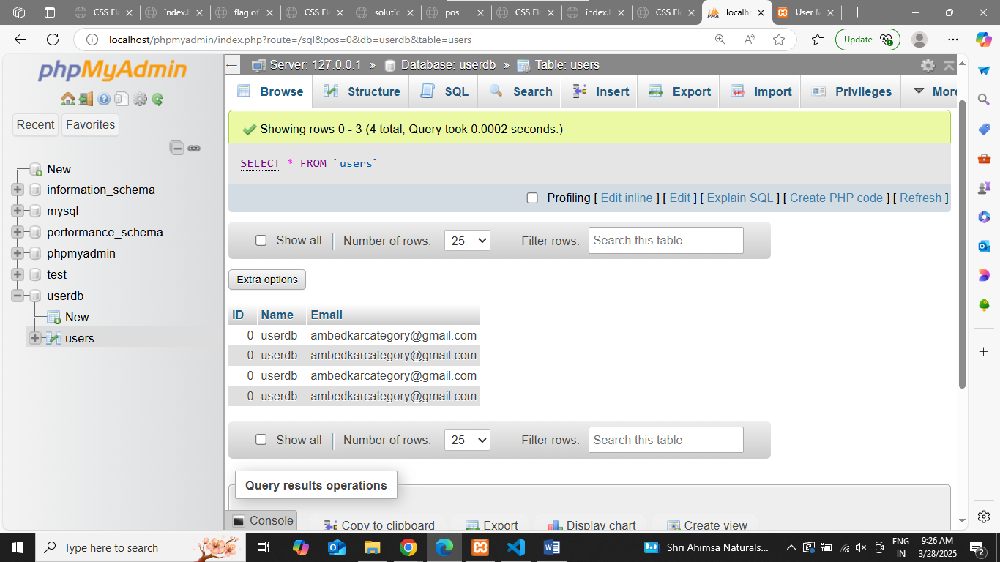

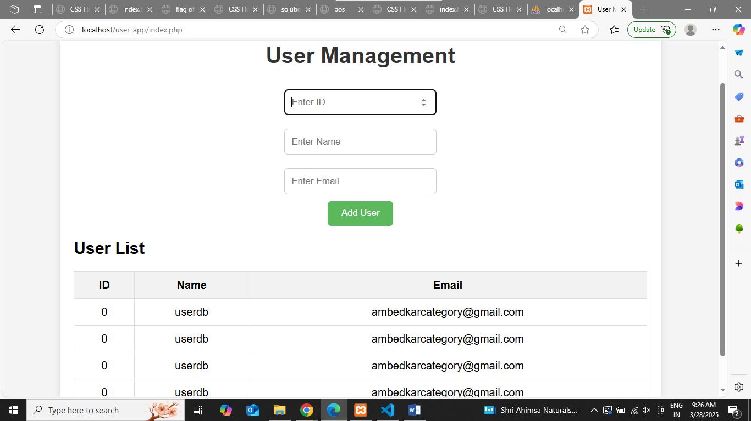

Conclusion
In this mini application, we used HTML to create the user interface, CSS to style the page, PHP to handle the server-side logic, and MySQL to manage user data in the database. XAMPP provided the local environment to run and test the application, combining all the necessary components into a seamless development process.
This simple application demonstrates the basics of full-stack web development, involving both client-side (HTML, CSS) and server-side (PHP, MySQL) components. It also showcases fundamental web development concepts like form handling, database interaction, and basic security measures
Assessment

Timely Submission  (7) | Presentation  (06) | Understanding  (12) | Total  (25) | Sign

